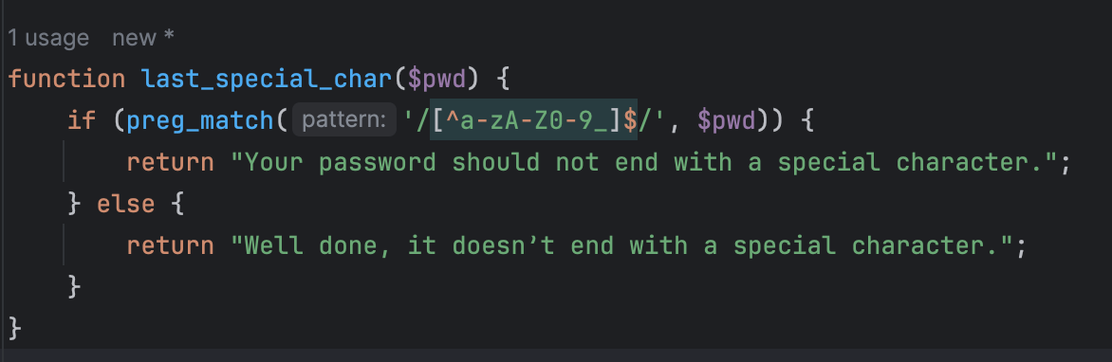
Description of test | Test data | Expected out | Actual Outcome | Comments and intended actions
Testing if my password checks work | 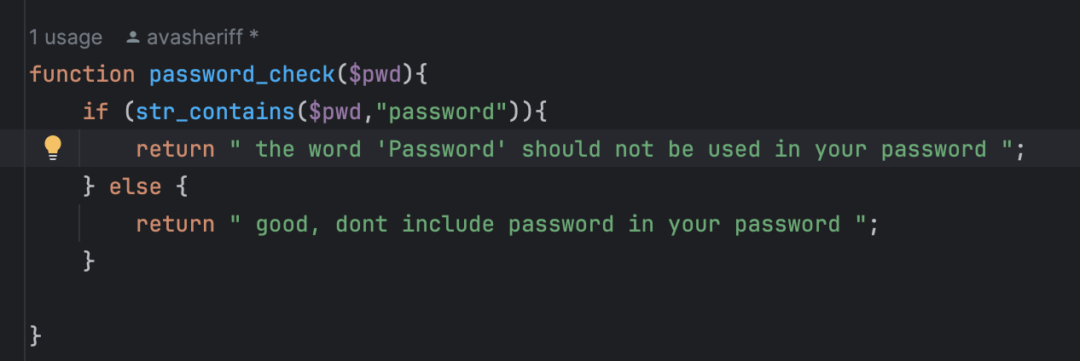  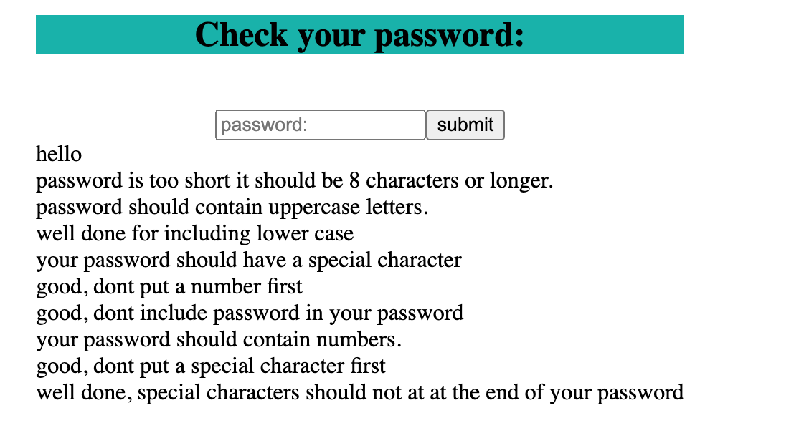  hello | It should say:  password is too short it should be 8 characters or longer.  password should contain uppercase letters.  well done for including lower case  your password should have a special character  good, dont put a number first  well done for not including password  your password should contain numbers.  good, dont put a special character first  well done, special characters should not at at the end of your password | 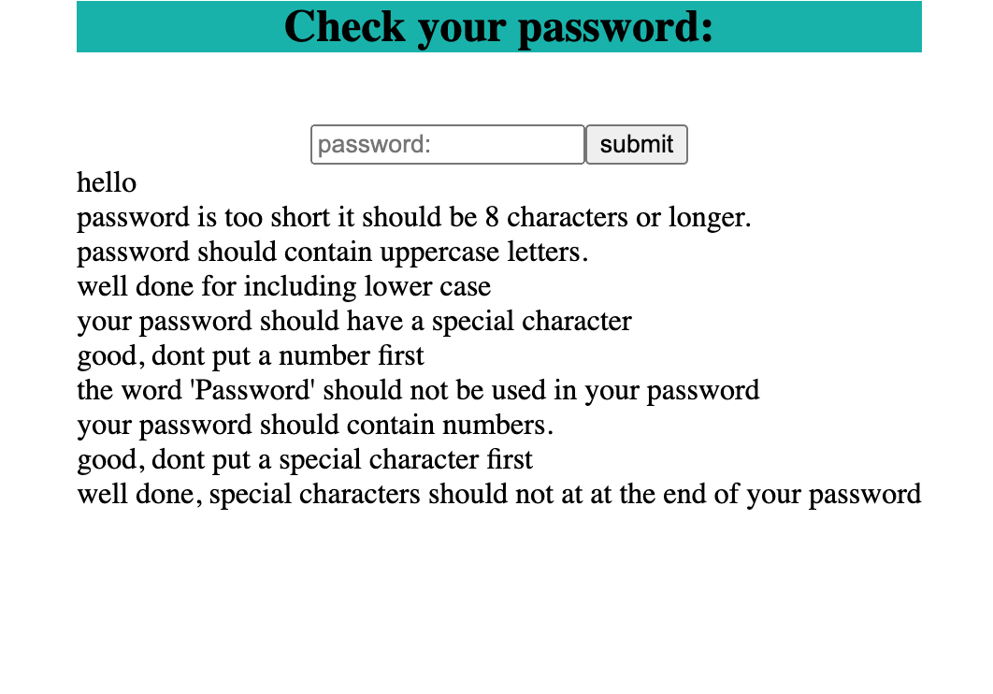  As we can see its saying that I shouldn’t inclue the word password when I havent | 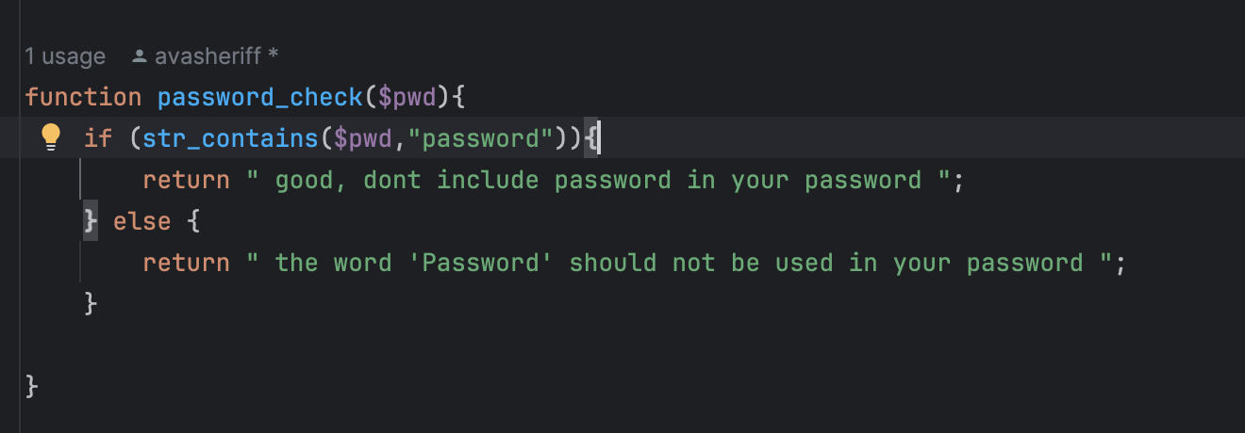  Here is my code,  we can see the if stament is checking if the input has the word password in,the problem with my code is that if it dose have the word password in then it outputs the wrong thing saying they havent included it, to fix this I just need to swap the staments around. We can see its right now
Checking with a valid input | HeLLo!45 | good length of a password  well done for including upper case  well done for including lower case  well done for including a special character  good, dont put a number first  good, dont include password in your password  well done, including numbers  good, dont put a special character first  well done, special characters should not at at the end of your password | 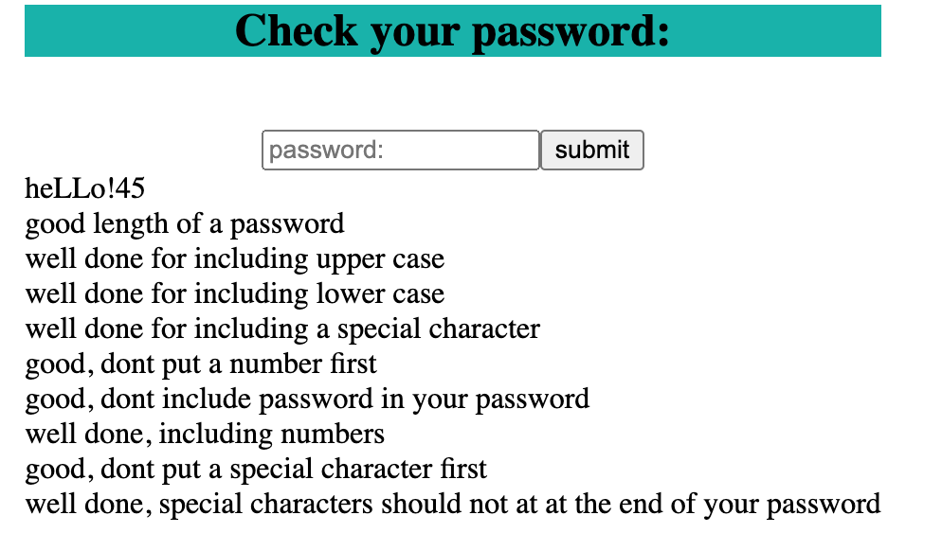 | This is all correct no changes
Having a number at the start and a special chariter at the end all the rest will be corret | 45heLLo! | 45heLLo!  good length of a password  well done for including upper case  well done for including lower case  well done for including a special character  dont put a number first  good, dont include password in your password  well done, including numbers  good, dont put a special character first  special characters should not at at the end of your password4 | 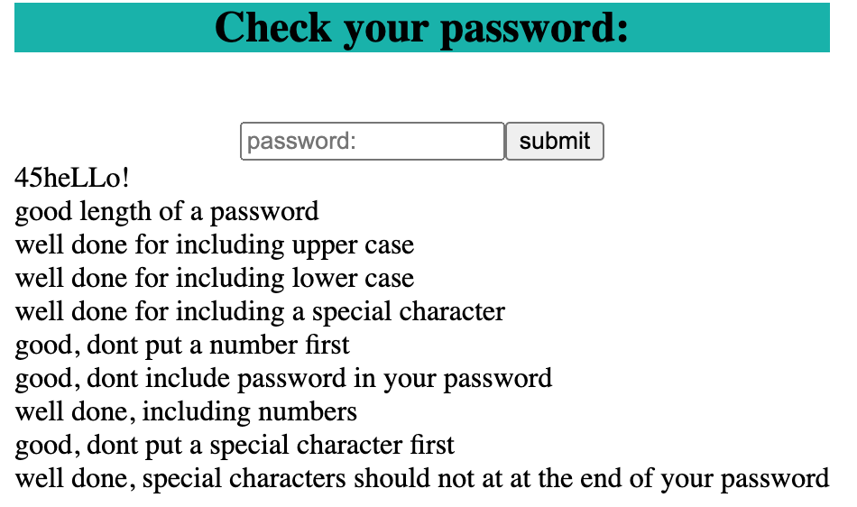  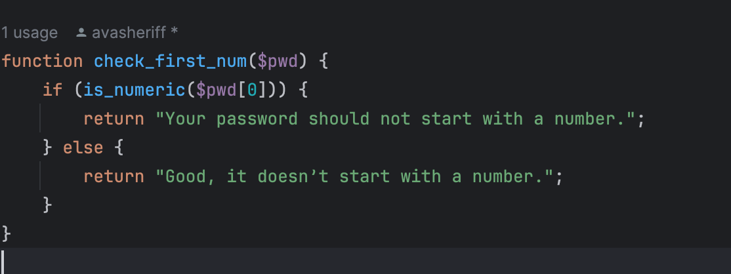  As we can see its saying well done for not putting number first and charcter last which we have done | 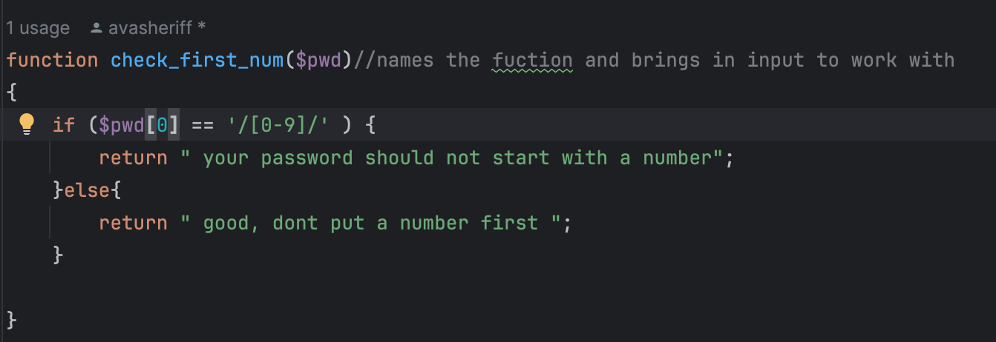  Here is my code for checking for the number first  here we can see the problem with my code was I was comparing the first letter to the actule string “[0-9]” this means its not comapring what we want I didn’t know how to fix this so I search up how to checkm for numbers and the built in fuction is numeric will check for you and will give us the correct answer.  I felt I was having the same problem with checking if the end charter was a special charter I had to find out but you can use preg_match and use the use $ simble after the list of other althnumerics to check the last digit, so this is the fixed code and the result of the fixes  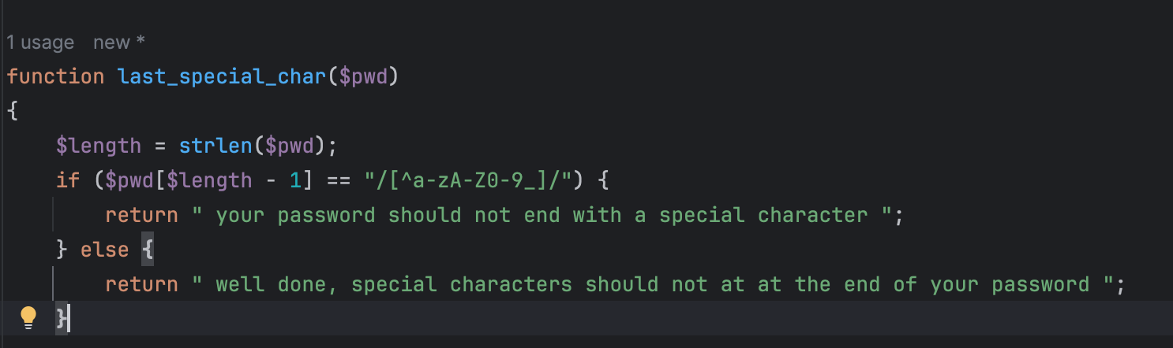  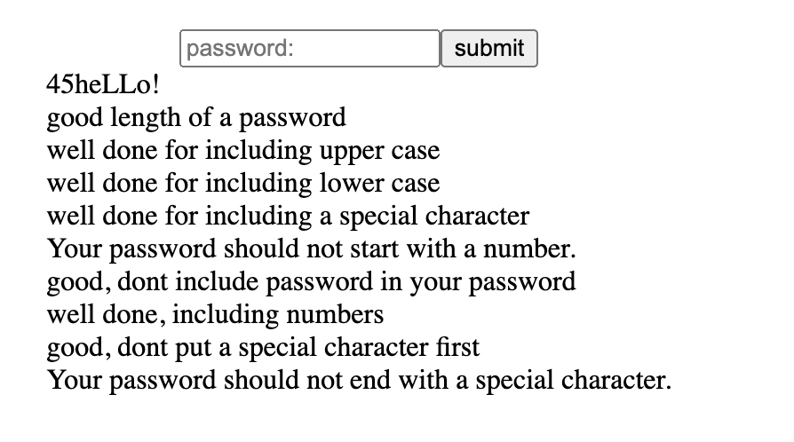
Inputting incorrect password which inculed password and a specal charter at the end but everything els eid correct | !passwordA45 | good length of a password  well done for including upper case  well done for including lower case  well done for including a special character  Good, it doesn’t start with a number.  the word 'Password' should not be used in your password  well done, including numbers  dont put a special character first  Well done, it doesn’t end with a special character. | 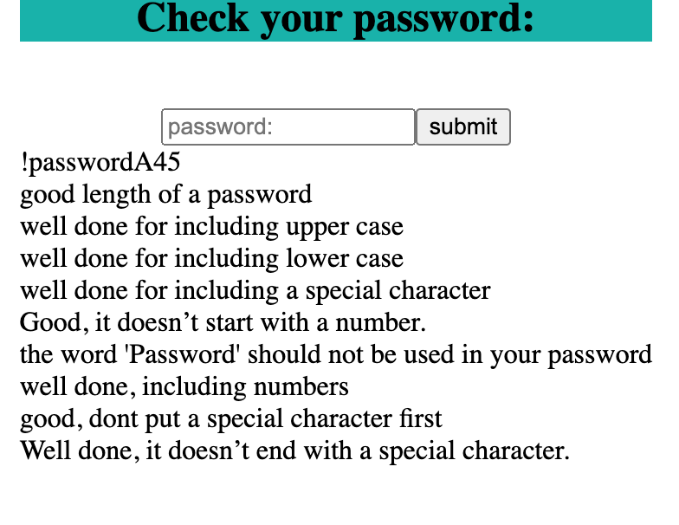  As we can see its saying there isnt a specal charter at the start when there is | 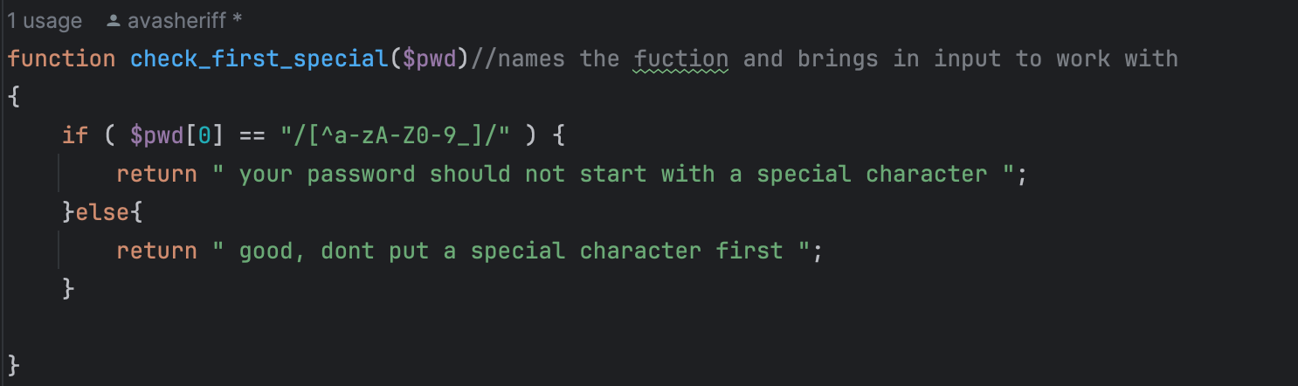  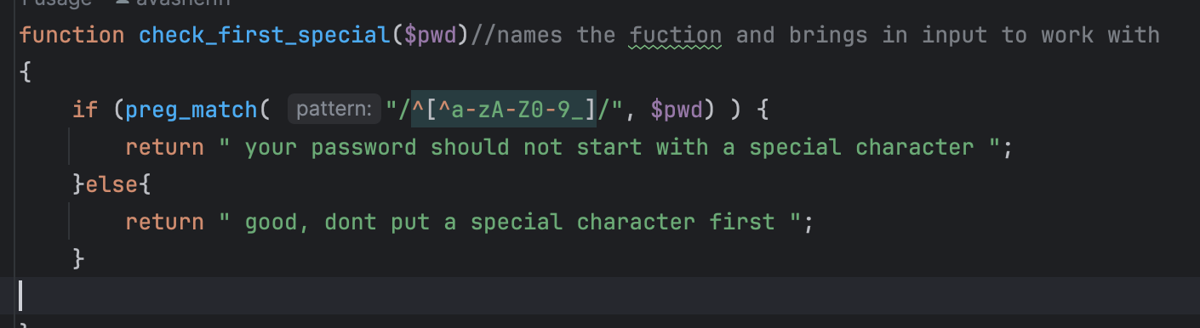  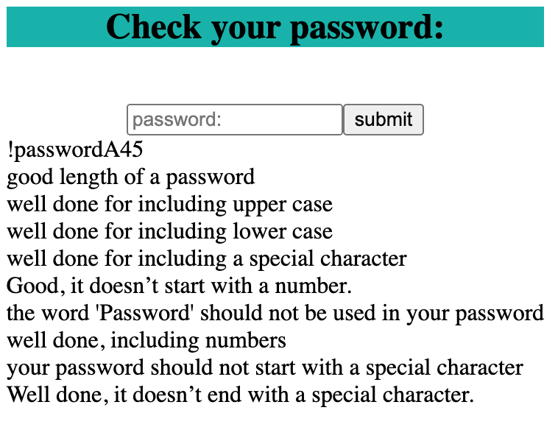  Here we can see the issue is the same as the last where its not comaring properly so the output isnt corret so it fix this we need to ajust how its comparing and I learned during my last search that ^ is that start of a string so if I use preg_match and add in a sybly ay the start of my alphnumerics so herer is my fixed code and my working webpage

